Bill Payment Business User Guide



Member FDIC

Home Page 1

Messages 2

Attention Required 2

Shortcut 2

Transaction Scheduled to Process 2

Since You Last Logged In 2

Payees Tab 2

Add a Payee 3

Add a Company 3

Add an Individual 4

View Payees 5

Import Payee 6

Manage Categories 7

Payments Tab 7

Single Payment 7

Recurring Payments 10

Scheduled Transactions 11

Transaction History 12

Calendar 13

Options Tab 13

Company Profile 13

Personal Profile 14

Contact Information 14

Change PIN 14

Default Page 15

Challenge Phrases 15

Manage Bill Pay Accounts 16

Default Accounts 16

Add New Account 16

e-Notifications 17

Event e-Notifications 17

Log out e-Notifications 17

Recurring e-Notifications 18

Reminders 18

Manage Users 19

Add New User 19

Reports 20

## Home Page

The Home Page is a snap shot of the user’s menu tabs available and the following bill pay activity:

1. New Messages
2. Attention Required
3. Short Cut (Anticipated Payments)
4. Transactions Scheduled to Process
5. Since You Last Logged In

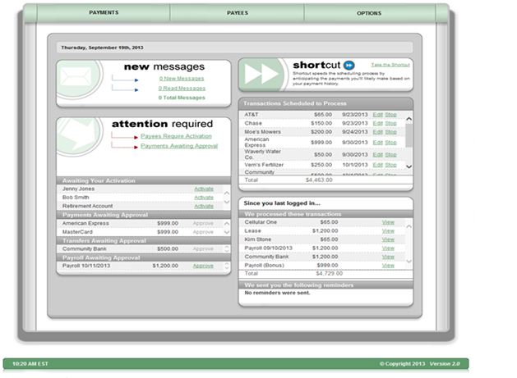

### Messages

This secure message center allows users to receive communications regarding Bill Pay.

* Secure messages will remain in the message center for 180 days or until they are deleted.

### Attention Required

* Displays notifications for payees requiring activation or transactions awaiting approval.

### Shortcut

* Provides a faster way to schedule anticipated payments based on the user’s previous bill payment history.

### Transaction Scheduled to Process

* Displays payments that are in a scheduled status with the options to “**Edit**” or “**Stop**” up until the processing time on the Process Date.

### Since You Last Logged In

* Displays payments that processed with the option to **“View”** the details and Reminders to pay bills.

## Payees Tab

After selecting **“Payees”** tab, users have the ability to add and manage payees:

* Add a Payee
* Import Payees
* View Payees
* Manage Categories

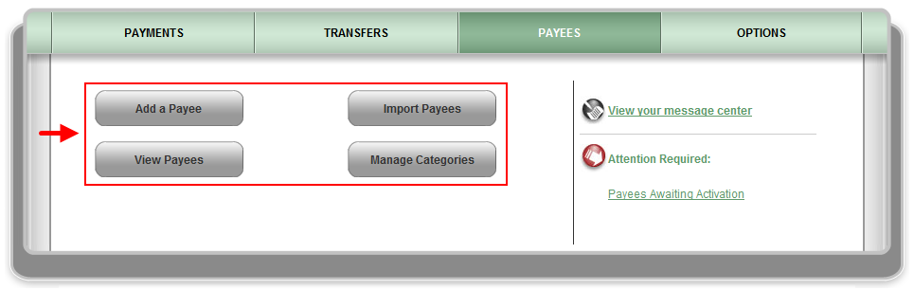

### Add a Payee

Allows users to add payees into the bill pay site.

**Three options to add a payee**:

1. Company
2. Individual
3. Bank or Credit Union

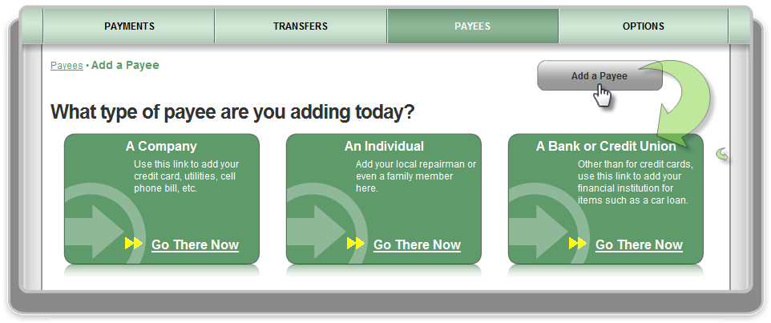



#### Add a Company

When adding a company, users will need to enter the information from their remittance statement.

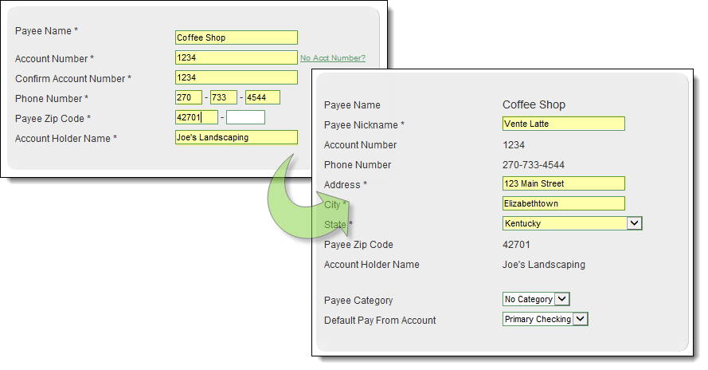



Bill Pay may locate the payee in the system based on the information entered on the previous screen. If the payee is not found in the system, users will need to enter in the payee’s address.

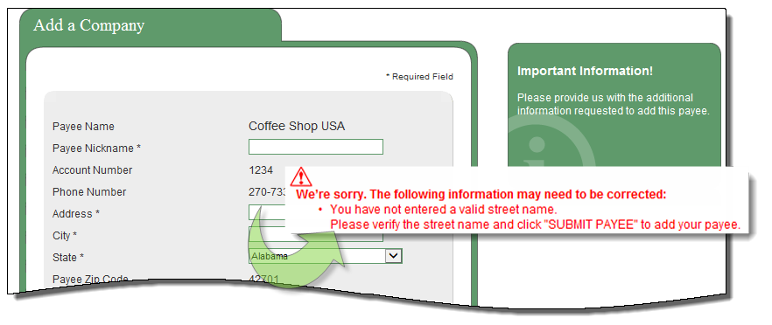

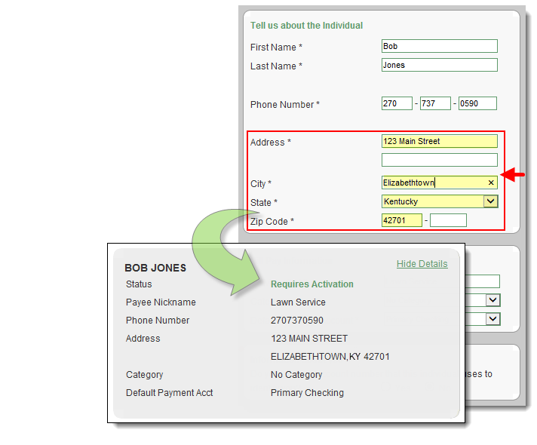**Mail a check**

* Users will be required to enter the payee’s address.
* After information has been entered, the payee requires activation.

#### Add a Bank or Credit Union

After users answer a challenge question successfully, they will be directed to the **“Add”** screen.

* **Types**: Loan, Credit Card, Checking, or Savings

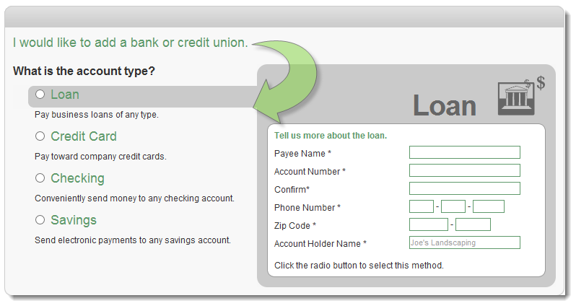

### View Payees

After clicking **“View Payees”**, users have the ability to manage their payees.

* **Pay –** Links to scheduling a single payment.
* **Edit –** Update the payee’s account information.
* **Delete** – Remove the payee from the list, however, their payment history will remain for **18 months**.

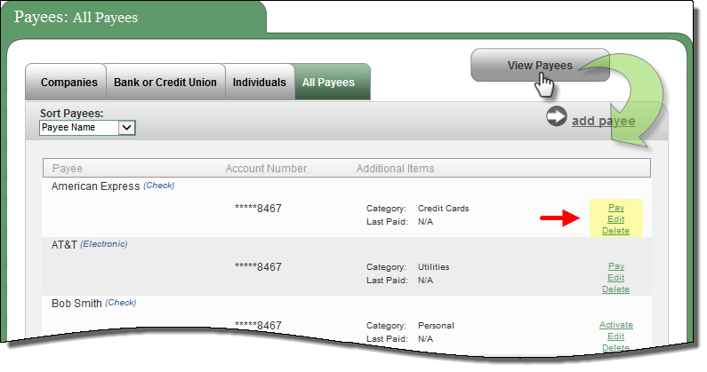

### Import Payee

After clicking **“Import Payees”**, users have the ability to upload payee records from “QuickBooks” or “Quicken.”

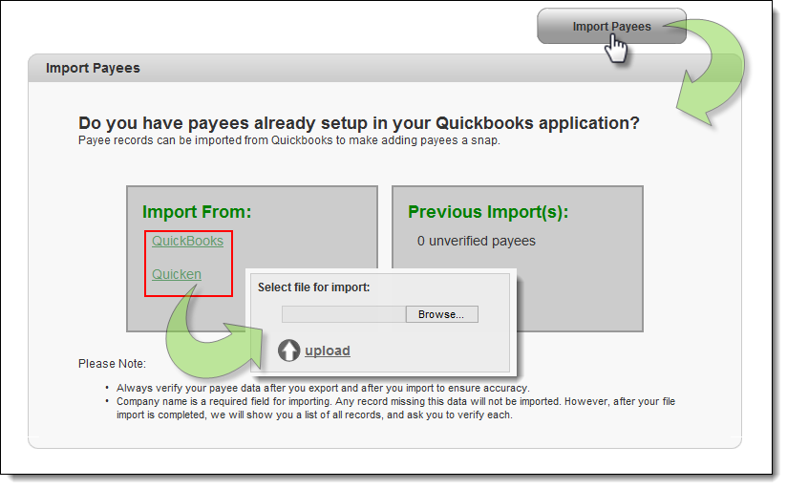

### Manage Categories

After clicking **“Manage Categories”**, users have the ability to manage multiple payees by creating personalized categories.

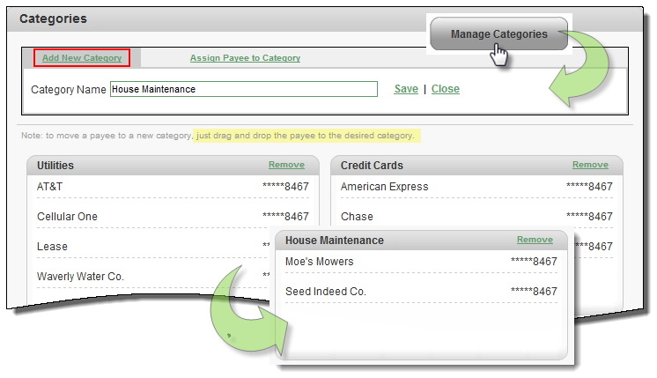

## Payments Tab

After clicking **“Payments”** tab, users have the ability to manage the following transactions, payroll, and payment history within this tab:

* Single Payment
* Recurring Payment
* Scheduled Transactions
* Transaction History
* Payroll Deposits
* Calendar

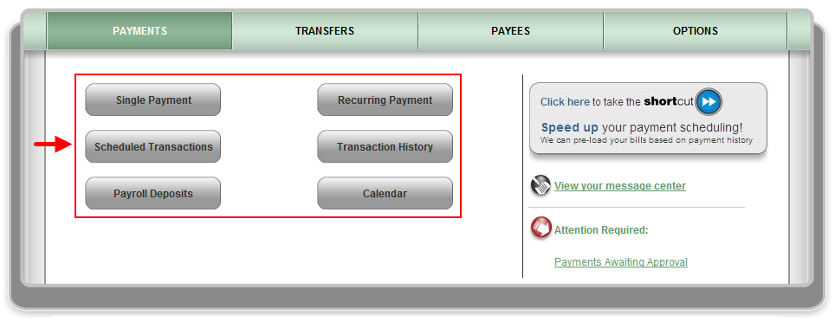

### Single Payment

After clicking **“Single Payment”**, users can schedule and edit single payments.

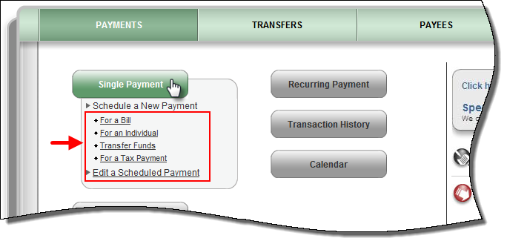

For single payments, users have the option to select a category and select a payee or payees they would like to pay.

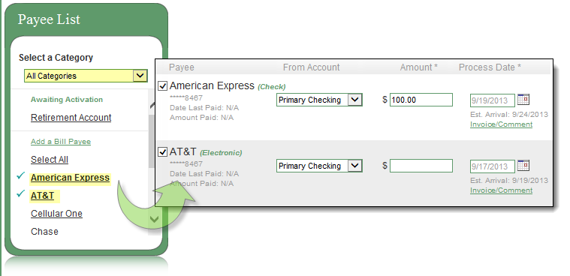

**Step 1:** Users will select a **“Pay From”** account and **“Amount”**

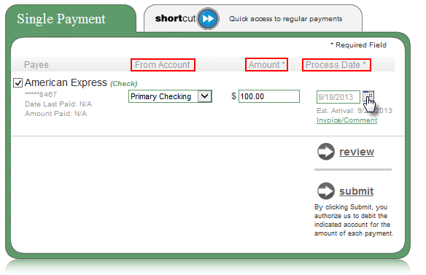



**NOTE:** *The user has the option to add and invoice and/or comment.*

**Step 2:** Select a process date from the calendar

* Payments only process Monday – Friday

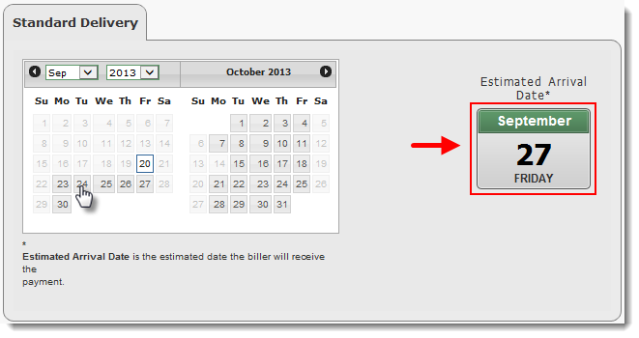

**Step 3**: Click **“Review”** to review payment information

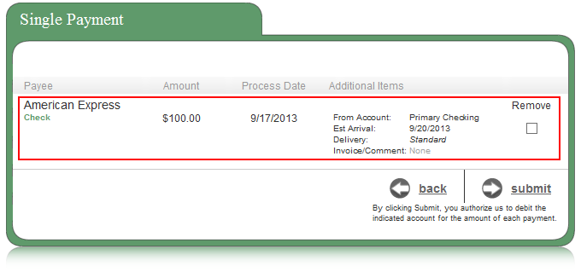



**NOTE:** *Users have the option to* ***“Remove”*** *a payment from this screen by selecting the applicable checkbox, or* ***“Submit”*** *to continue the scheduling process.*

**Step 4**: Click **“Submit Payment”** to receive the Confirmation Number

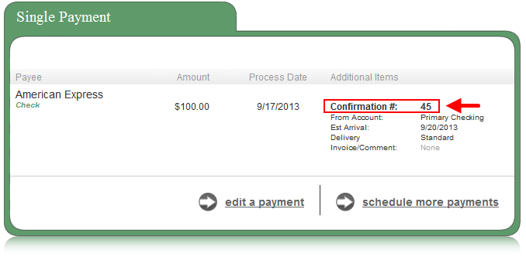

### Recurring Payments

These are payments that are paid on a recurring basis such as *mortgages, rent or loans.*

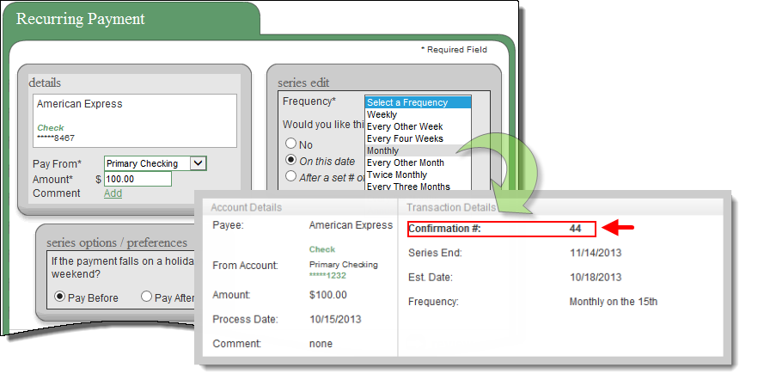

### 

### Scheduled Transactions

A **“scheduled”** payment allows users to search for and **“Edit”** or **“Stop”** payments that have not yet been processed. Users will also be able to view details of the payment.

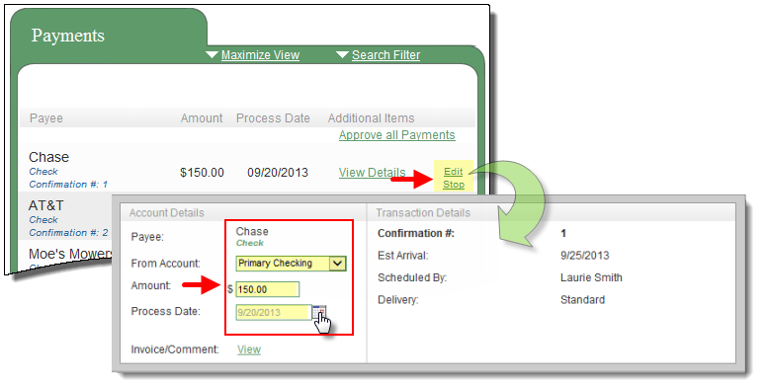

### Transaction History

These are user’s payments that have processed and paid out.

* Bill Pay stores **18 months** of payment history.
* Users have the option to “View Details”

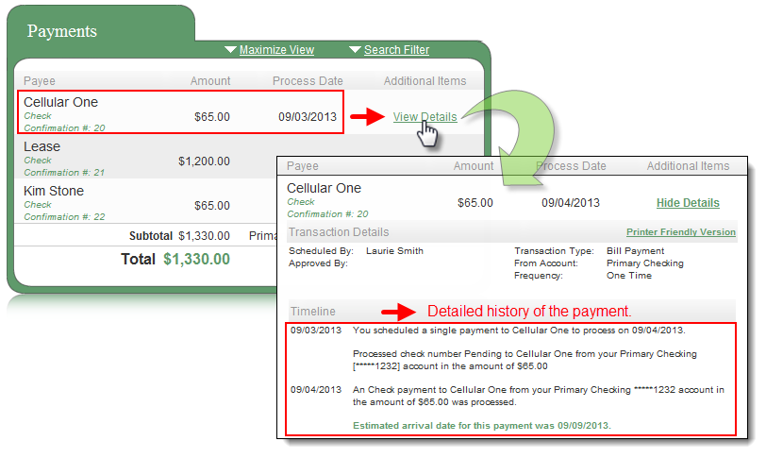

### Calendar

Allows users to see and an overview of the following months’ bill payment activity:

1. Scheduled Payments
2. Action Required
3. Reminders
4. Processed Payments

* It displays **18 months** of activity with the ability to view previous/upcoming months.
* The monthly calendar will display payment activity that has **processed** as well as payments in a **scheduled** status.

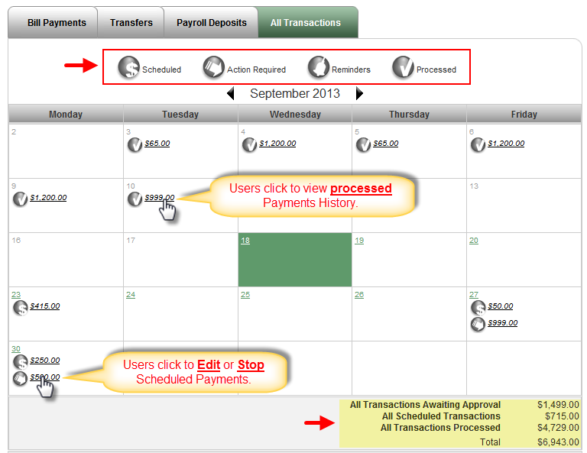

## Options Tab

Users have several options available to assist in managing their bill pay account.

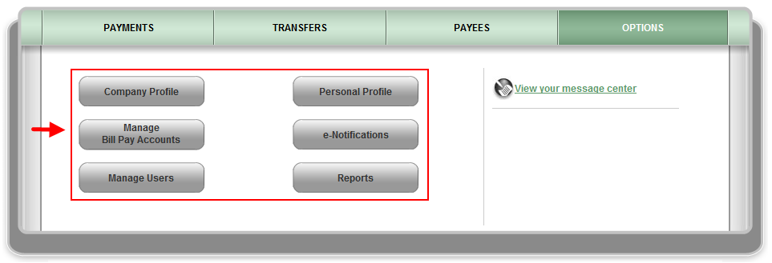

### Company Profile

Allows users to update their **Company Info** and turn **Dual Signatures** on or off.

* **Dual Signatures** is a security feature that forces the business to have two sub-users approve transactions.

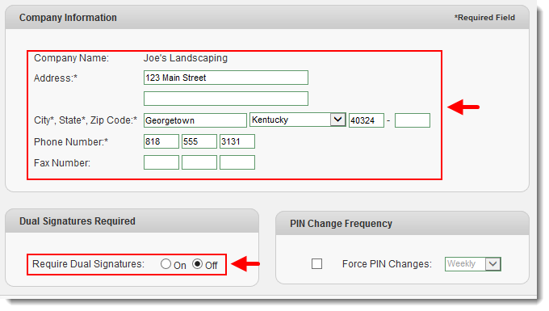



**NOTE:** *If users turn this on, they must locate the second user, and turn on the “approval authority” permission for them to be able to approve transactions.*

### Personal Profile

This is the sub-user’s account profile for the business bill pay account:

#### Contact Information

The Bill Pay users can update their Email, Phone and Mobile Devices.

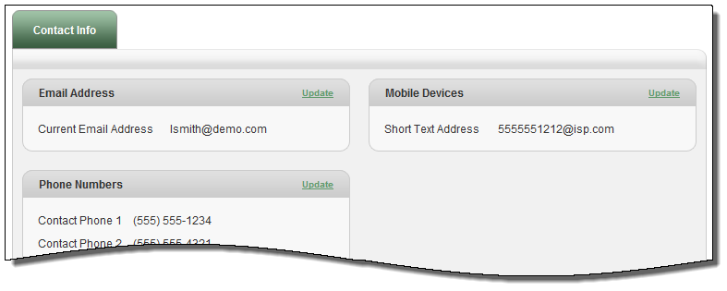

#### Change PIN

Users may have access to change their PIN. When changing the PIN, they must complete the **“Change PIN”** parameters set by the Institution.

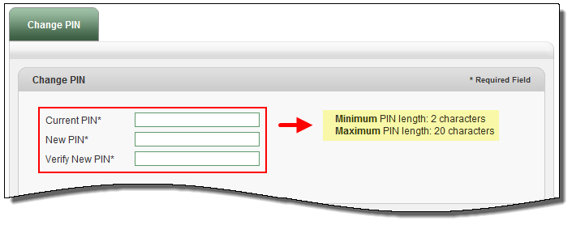



**NOTE:** *After completing these steps please select the “Submit” button. Your new PIN should be used the next time you log into your bill pay site.*

#### Default Page

Allows users to change their default page to display a different page each time they log in.

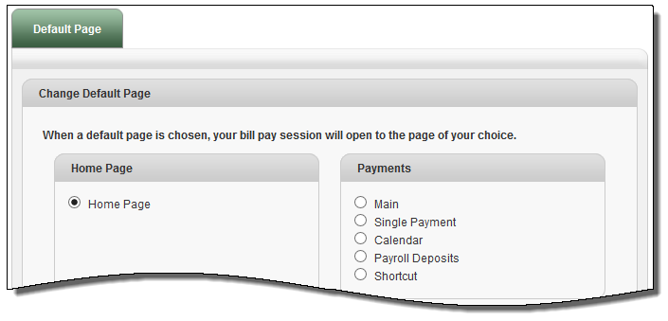

#### Challenge Phrases

Allows users to view all of their challenge phrase questions they have on file and add any additional ones available.

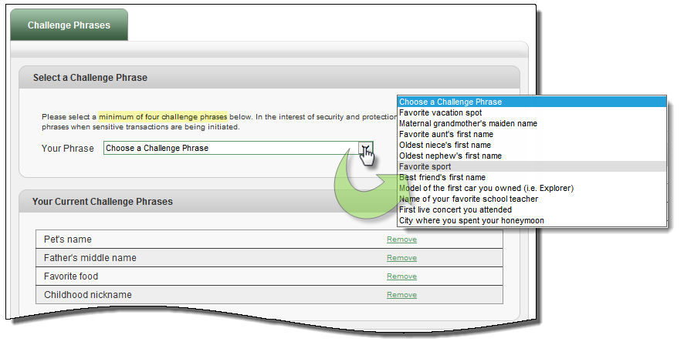

### Manage Bill Pay Accounts

Users can view and manage their additional Pay from Accounts.

#### **Default Accounts**

Users that have multiple pay from accounts may change their Default Pay from Account, Edit and Delete an account if they no longer use it.

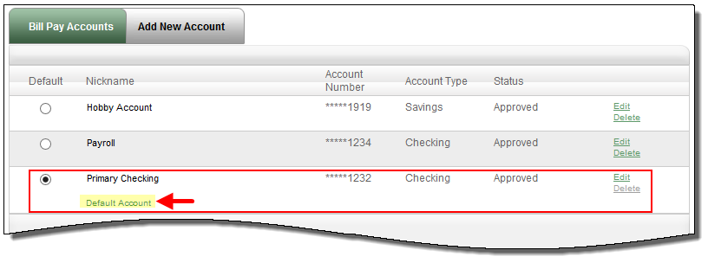

#### Add New Account

Allows users to add additional “**Pay From Accounts**.”

* Each additional pay from account will require approval from the Institution.

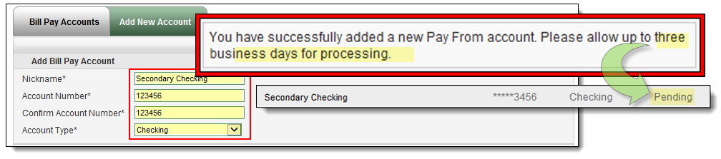

### 

### e-Notifications

Allows users to monitor activity and assist with detecting fraud on their bill pay account.

e-notifications can be sent to email, text message, or both.

#### Event e-Notifications

These are sent to users when a particular event occurs.

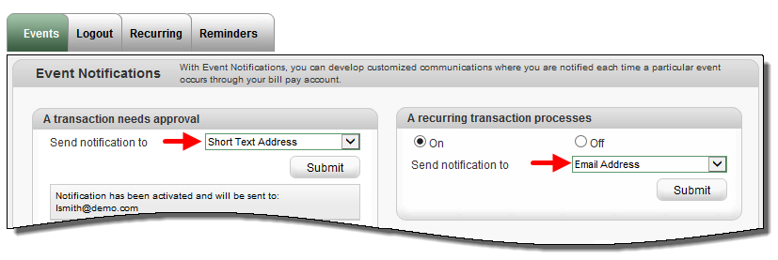

#### Log out e-Notifications

These are sent to users each time the subscriber logs out of bill pay.

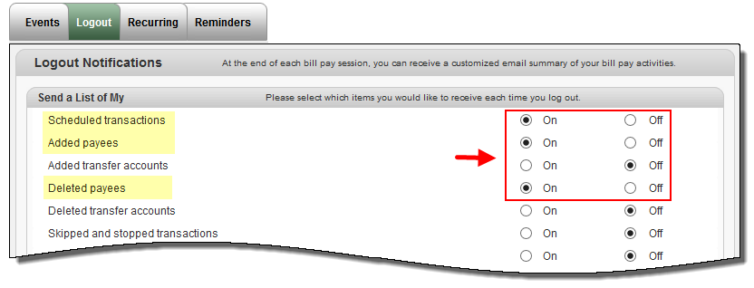

#### Recurring e-Notifications

These are sent on the occurrence of the user’s choice.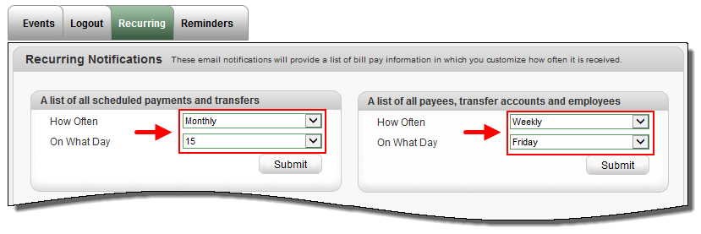

#### Reminders

These are reminders for users to pay a bill. Users also have the option to add the reminder to their **Microsoft Outlook Calendar.**

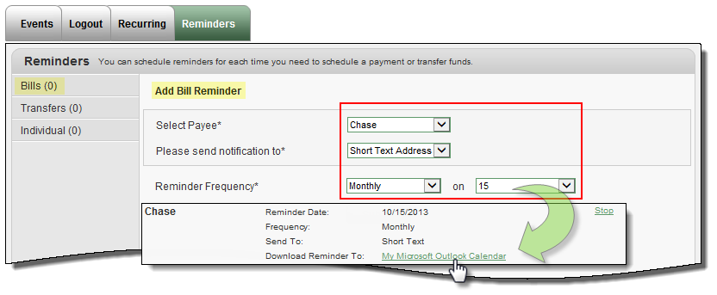

### 

### Manage Users

Allows the business to add as many admin users as they need to assist them in managing their business bill pay account.

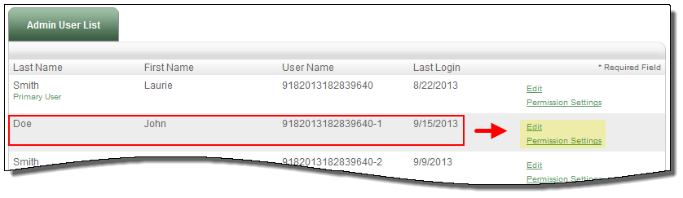

### Add New User

Business users can turn this permission on for those sub-users who will be approving

transactions.

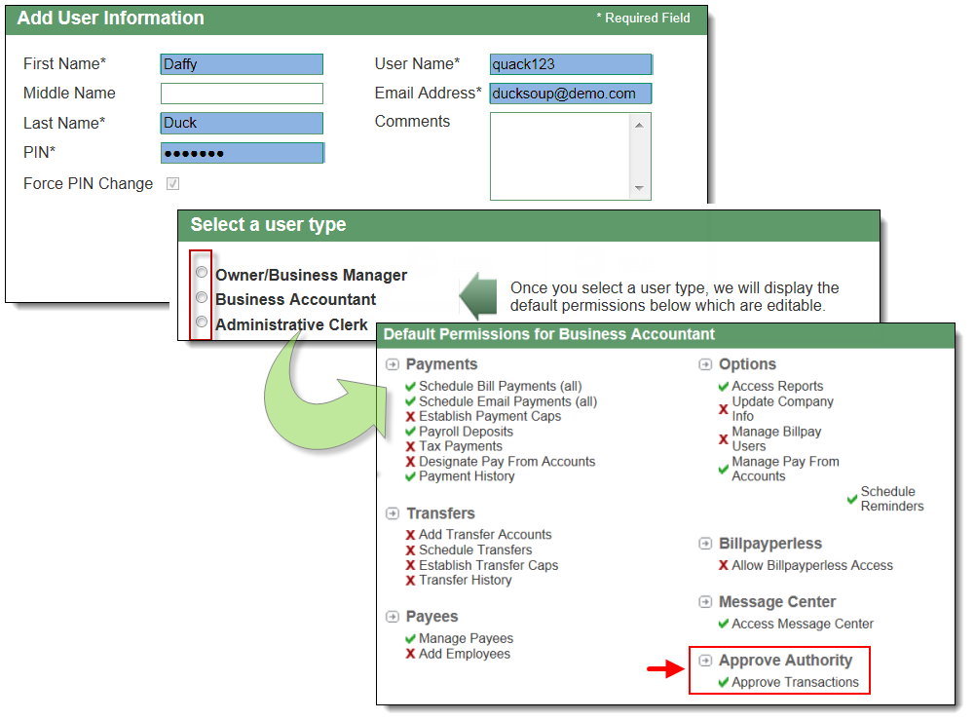

### 

### Reports

To assist users with managing the details of their account, there is a **“Reports”** section. The reports can be exported to Microsoft Excel.

